**POWER BI ASSIGNMENT-5**

Q1. Format as per condition

**Requirement**

1. Need to show case the Revenue as per the State.

**Step-1**. Need to calculate Revenue, Revenue = Quantity*Unit price.

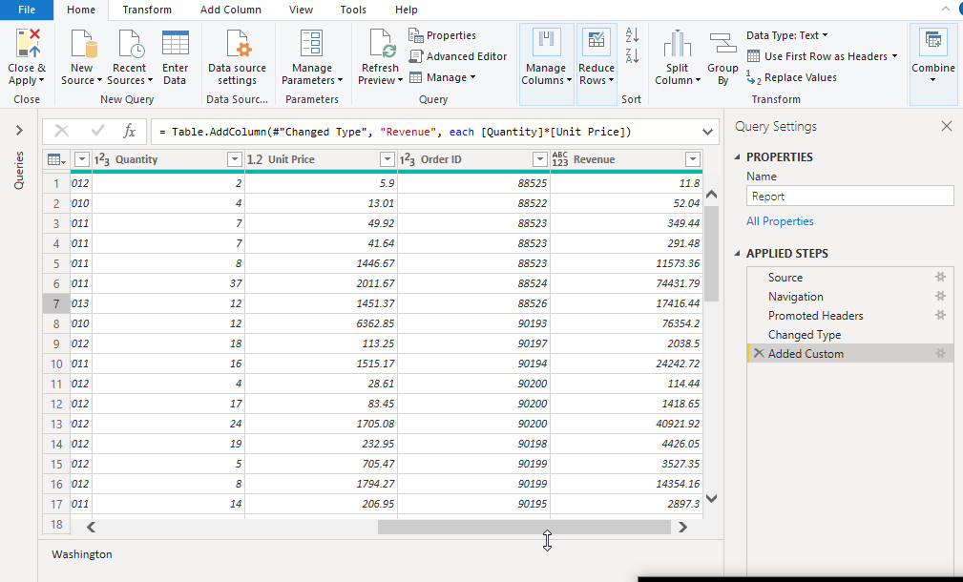

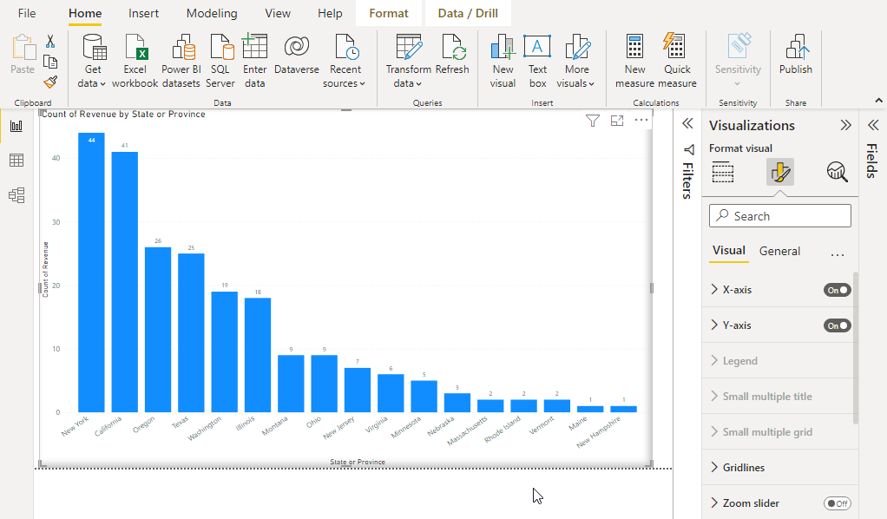

1. Create a new column as per following condition as per the States
2. Sales Range
3. Less 100
4. 1001 to 5000
5. 6000 to 10000
6. 11000 to 15000
7. 16000 to 20000
8. 21000 to 25000
9. Above 25000

**Step-2.** Using conditional column we can add a new column based on above requirement

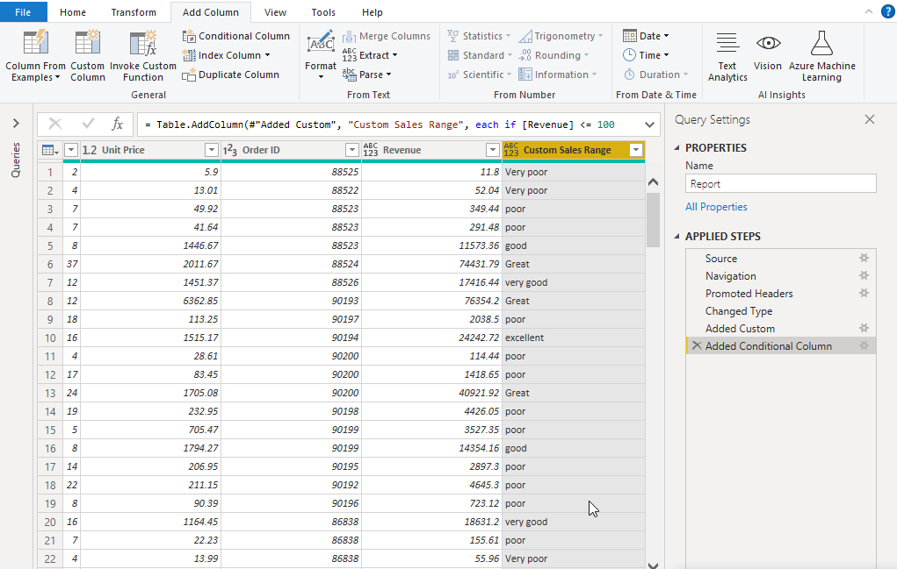

1. Create a new column as per following condition as per the Product Category where for:
2. Furniture it should show “Office Infra”
3. Other it should show “Non-Office Infra”

